# Articles:

## Effect of Pressure on solidification of metallic materials (2012):

JJ Sobczak, L Drenchev, R Asthana

* 196 MPa pressure increases the heat transfer by factor of 15 (for al-si) compared to atmosphere pressure, because of improved thermal contact between mould and metal.
* Effect of 34 MPa  in casting 413 Al-Si:
  + Alpha-phase volume increased from 21.87% to 46.23 %.
  + Eutectic Si content increased by ~20 wt%.
  + Eutectic temperature increased by 5 degrees C.
* formula for estimating the effect of pressure and ultrasonic vibration on nucleation using the Clausius-Clapeyron equation

## Solidifying pressure and microstructure of AlSi10Cu3 in die sleeve in high pressure casting

X. P. Hu, G. Q. Zhao & W. M. Wang

* nothing

# Effects of Sr and pressure on microstructure, mechanical and wear properties of near eutectic Al–Si piston alloys

Pratheesh et al.

* Sr 0.04% changes silicon morphology from platelets to finer fiber-like structures.
* UTS 155 MPa 🡪 180 MPa
* Hardness 100 HB 🡪 115 HB
* Elongation 2.5% 🡪 2.2% (2% for squeeze cast)
* T6 heat treatment: Si coarsening 🡪 fragmentation 🡪 spheroidisation

# The Influence of Intensification Pressure on the Gate Microstructure of AlSi3MgMn High Pressure Die Castings

Otarawanna et al.

* 2 values of intensification pressure: 13 MPa and 61 MPa
* Higher pressure caused shear banding in the gate.
* Higher pressure 🡪 lower porosity
* Shear banding causes cracks and severe macrosegregations

# Casting Characteristics of Aluminum Die Casting Alloys

Makhlouf M. Makhlouf, Diran Apelian, 2002

* The sludge factor (SF) is most important in determining the sludge formation tendency of the alloy. $SF=\left(1 x wt\% Fe\right)+\left(2 x wt\% Mn\right)+(3 x wt\% Cr)$
* Slower cooling favors the formation of sludge.
* Sludge does not form during holding at 670 °C or 720 °C
* In fast cooling, no needle-like or Chinese script sludge was formed, only block-like

# Influence of Sr and Mn Additions on Intermetallic compound Morphologies in Al-Si-Cu-Fe Cast Alloys

Peyman Ashtari, Hiroyasu Tezuka and Tatsuo Sato 2003

* In the absence of Mn, no Chinese Script or sludge forms
* In high cooling rate, Sr and Mn additions transform needle-like beta into Chinese script

# Influence of modification, solidification conditions and heat treatment on the microstructure and mechanical properties of A356 aluminum alloy

Shabestari, F. Shahri 2004

* A356 alloy
* Greatest improvement of Sr observed with elongation at slow solidification rates
* At higher solidification rates, Sb is more effective than Sr
* The best prediction of tensile properties is size and number of silicon particles per unit area.

# Effect of copper and solidification conditions on the microstructure and mechanical properties of Al-Si-Mg alloys

Shabestari, H. Moemeni 2004

* A356 alloy
* The secondary dendrite arm spacing depends on chemical composition of the alloy, cooling rate, local solidification time and temperature gradient [[1]](http://www.sciencedirect.com/science/article/pii/S0924013604007083#BIB1) and [[9]](http://www.sciencedirect.com/science/article/pii/S0924013604007083#BIB9)
* The tensile properties most affected by variations in DAS are ultimate tensile strength (UTS) and percent of elongation [[1]](http://www.sciencedirect.com/science/article/pii/S0924013604007083#BIB1) and [[10]](http://www.sciencedirect.com/science/article/pii/S0924013604007083#BIB10).
* Ultimate tensile strength and percent of elongation increases simultaneously by increasing cooling rate of the alloy.

# The relationship between Dendrite Arm Spacing and Cooling Rate of Al-Si casting alloys in high pressure die casting

Jae-ik Cho, et al. 2012

* Increment of cooling rate up to 110 °C/sec affected the eutectic and solidus temperature of both alloys. Therefore, solidification temperature range was greatly decreased, as much as 23 °C
* Strong proportional relationship between SDAS and cooling rate in HPDC process.
* Approximate cooling rate of the die-casting can be successfully estimated
* 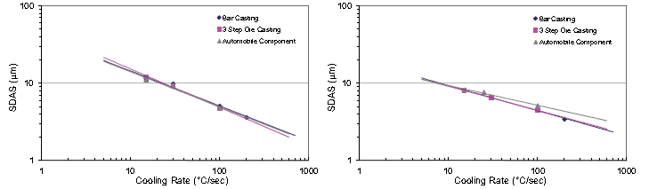

# Role of modification and melt thermal treatment processes on the microstructure and tensile properties of Al–Si alloys

A.M. Samuel et al. 2015

- A356

* According to Hafiz and Kobayashi [[11]](http://www.sciencedirect.com/science/article/pii/S0261306915002514#b0055), Sr modification has little effect on the yield strength of the A356 alloy, but can moderately improve the tensile strength. The main impact of Sr modification is on the ductility, where additions of 240 ppm Sr to the A356 alloy melt can increase the elongation from 8.03% to 22.2% [[12]](http://www.sciencedirect.com/science/article/pii/S0261306915002514#b0060)
* The results of Jie et al.[[12]](http://www.sciencedirect.com/science/article/pii/S0261306915002514#b0060) show that superheating an A356 alloy melt to 810 °C can improve the tensile properties, especially the ductility (from 5.0% to 8.5%). The work of Wang et al. [[13]](http://www.sciencedirect.com/science/article/pii/S0261306915002514#b0065)shows that the MTT process can greatly improve the elongation, by almost 112%.

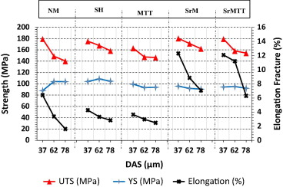

Conclusions:

* Cooling rate and modification level seem to have no significant influence on the alloy yield strength in the as cast condition regardless the type of melt treatment used.
* Aging (solution heat treatment) for 8h and Mg2Si particles have positive effect on mechanical properties
* Sr effect on tensile strength is positive, but not related to Si morphology !?

# Effect of strontium on the kinetics of formation and segregation of intermetallic compounds in A380 aluminum alloy

S. G. Shabestari et al.

* A380
* In high pressure die casting aluminum alloys, iron is intentionally added to the melt in range of 0.8–1.1 wt% to prevent molten metal soldering to the die [[23]](http://www.sciencedirect.com/science/article/pii/S0925838808020100#bib23) and [[24]](http://www.sciencedirect.com/science/article/pii/S0925838808020100#bib24)
* Strontium addition delays the formation of intermetallic compounds in the melt and also decreases the settling velocity of intermetallic particles.
* Avrami equation for volume fraction of sludge:
* f(t)=0.441[1−exp(−0.10t^0.5758)] For un−modified A380   melt
* f(t)=0.441[1−exp(−0.18t^0.3787)] For Sr−modified A380   melt
* Gravity effect on setting of sludge, modelled with stokes equation

# Microstructure, tensile properties and fracture behavior of high temperature Al-Si-Mg-Cu cast alloys